Testbench

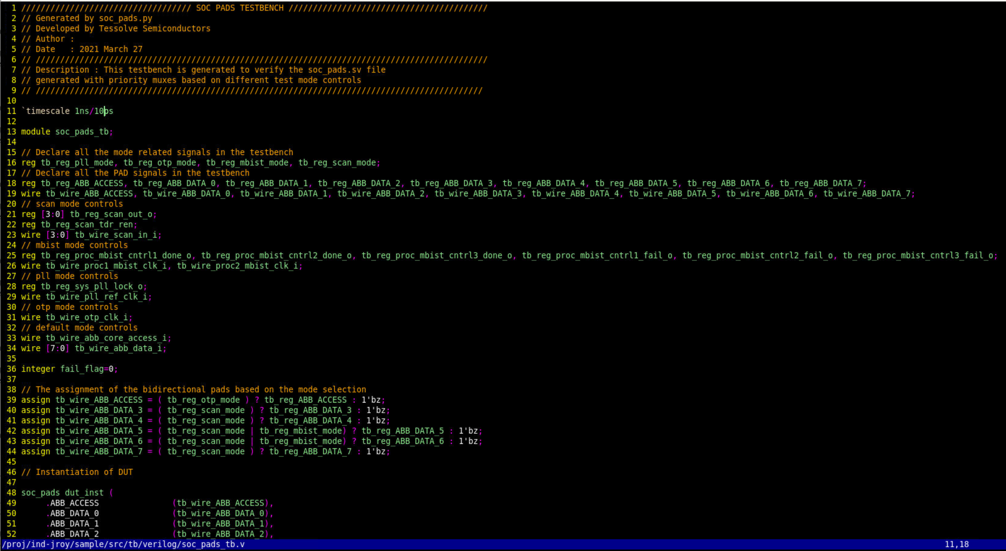

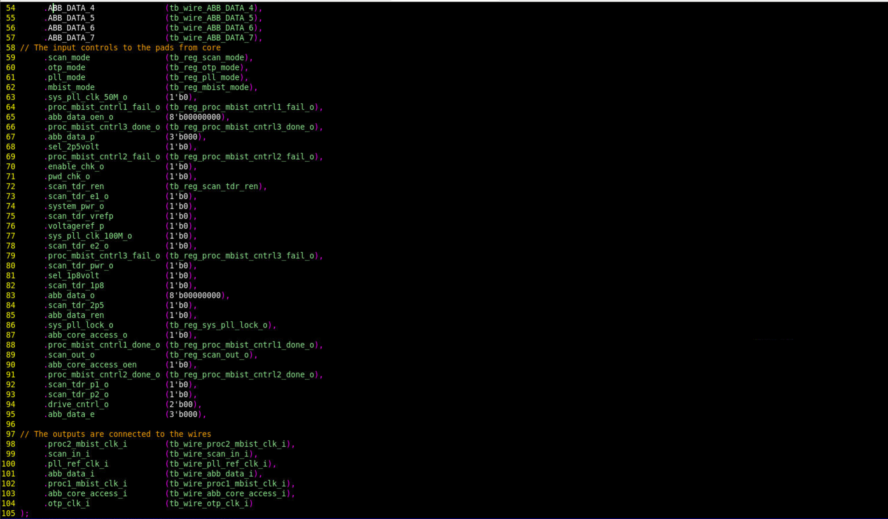

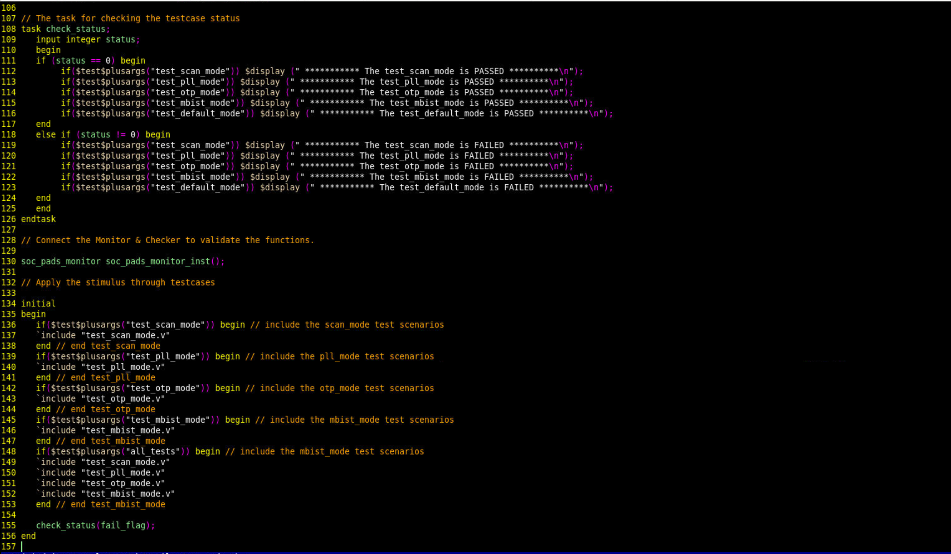

The Monitor separate file named (soc_pads_monitor.v)

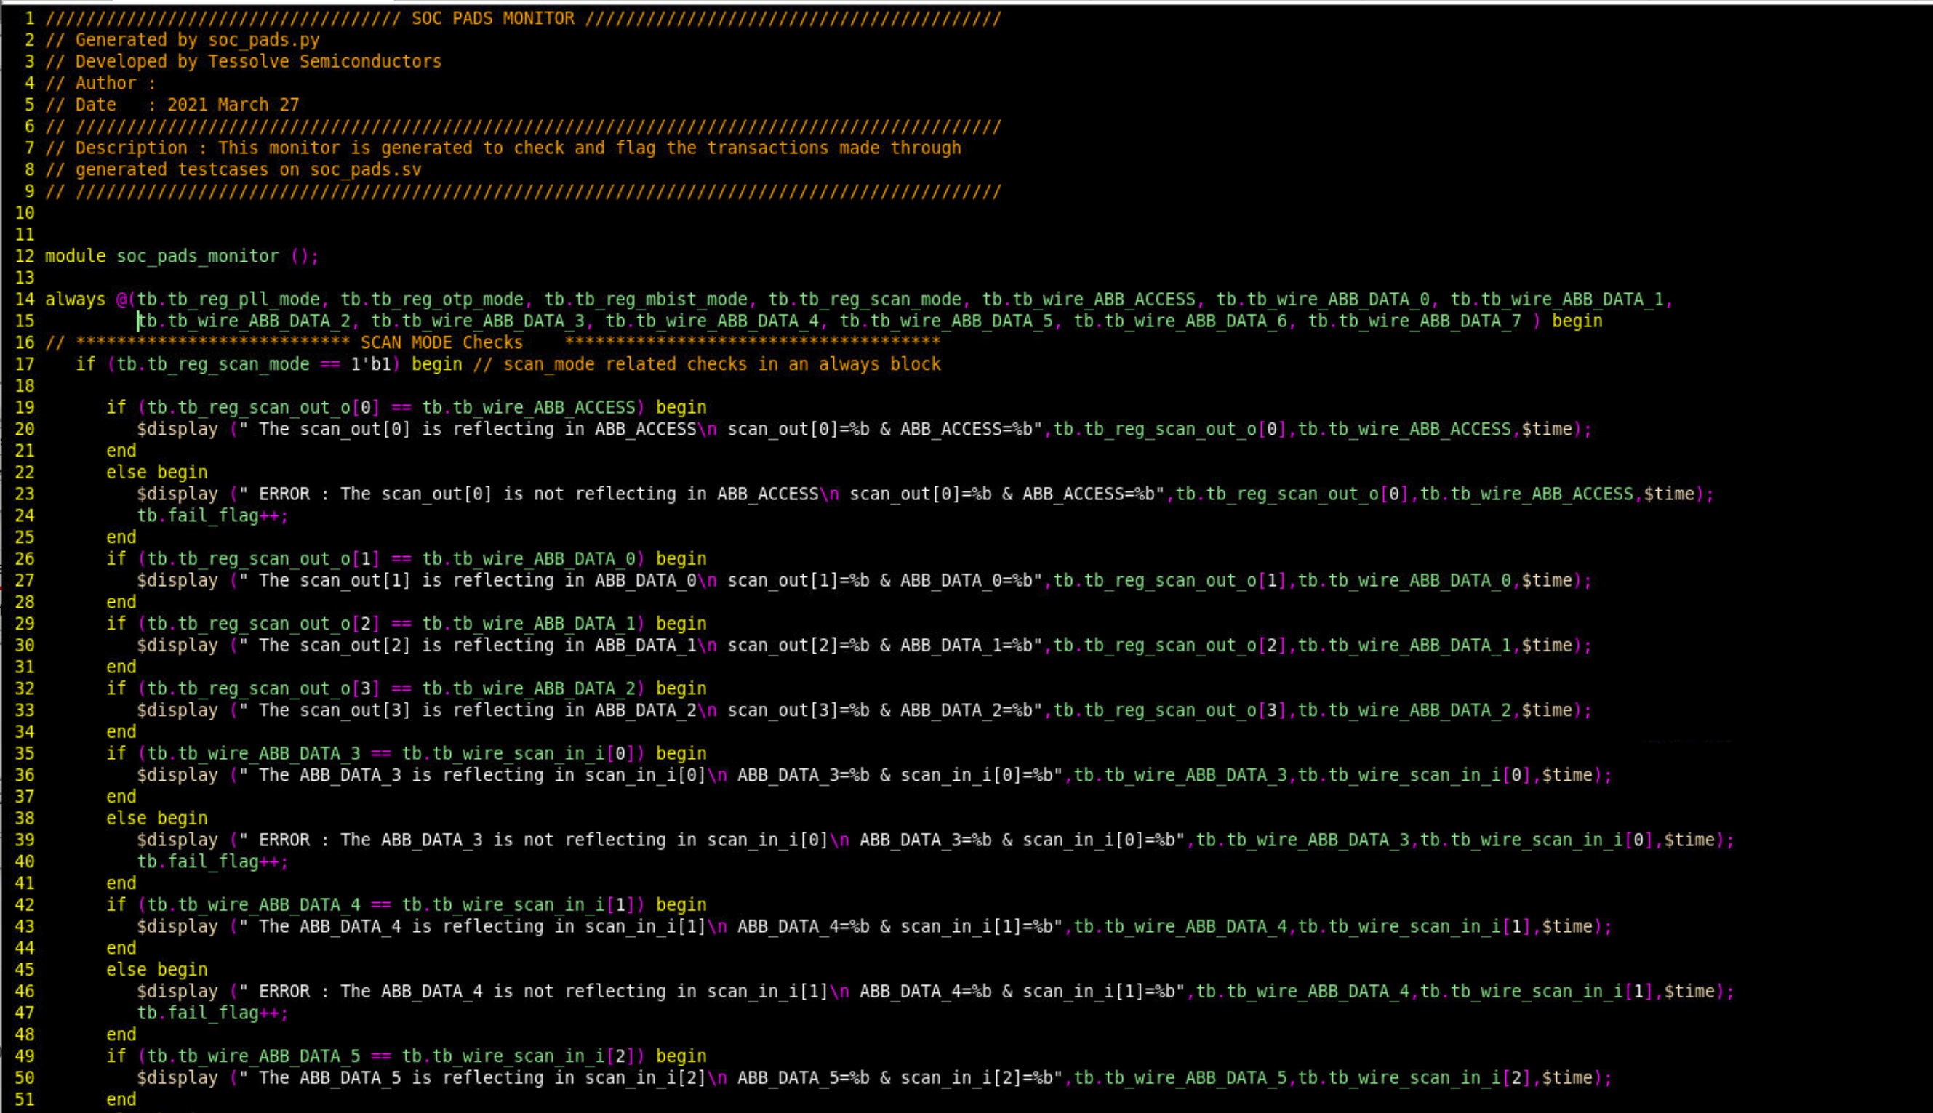

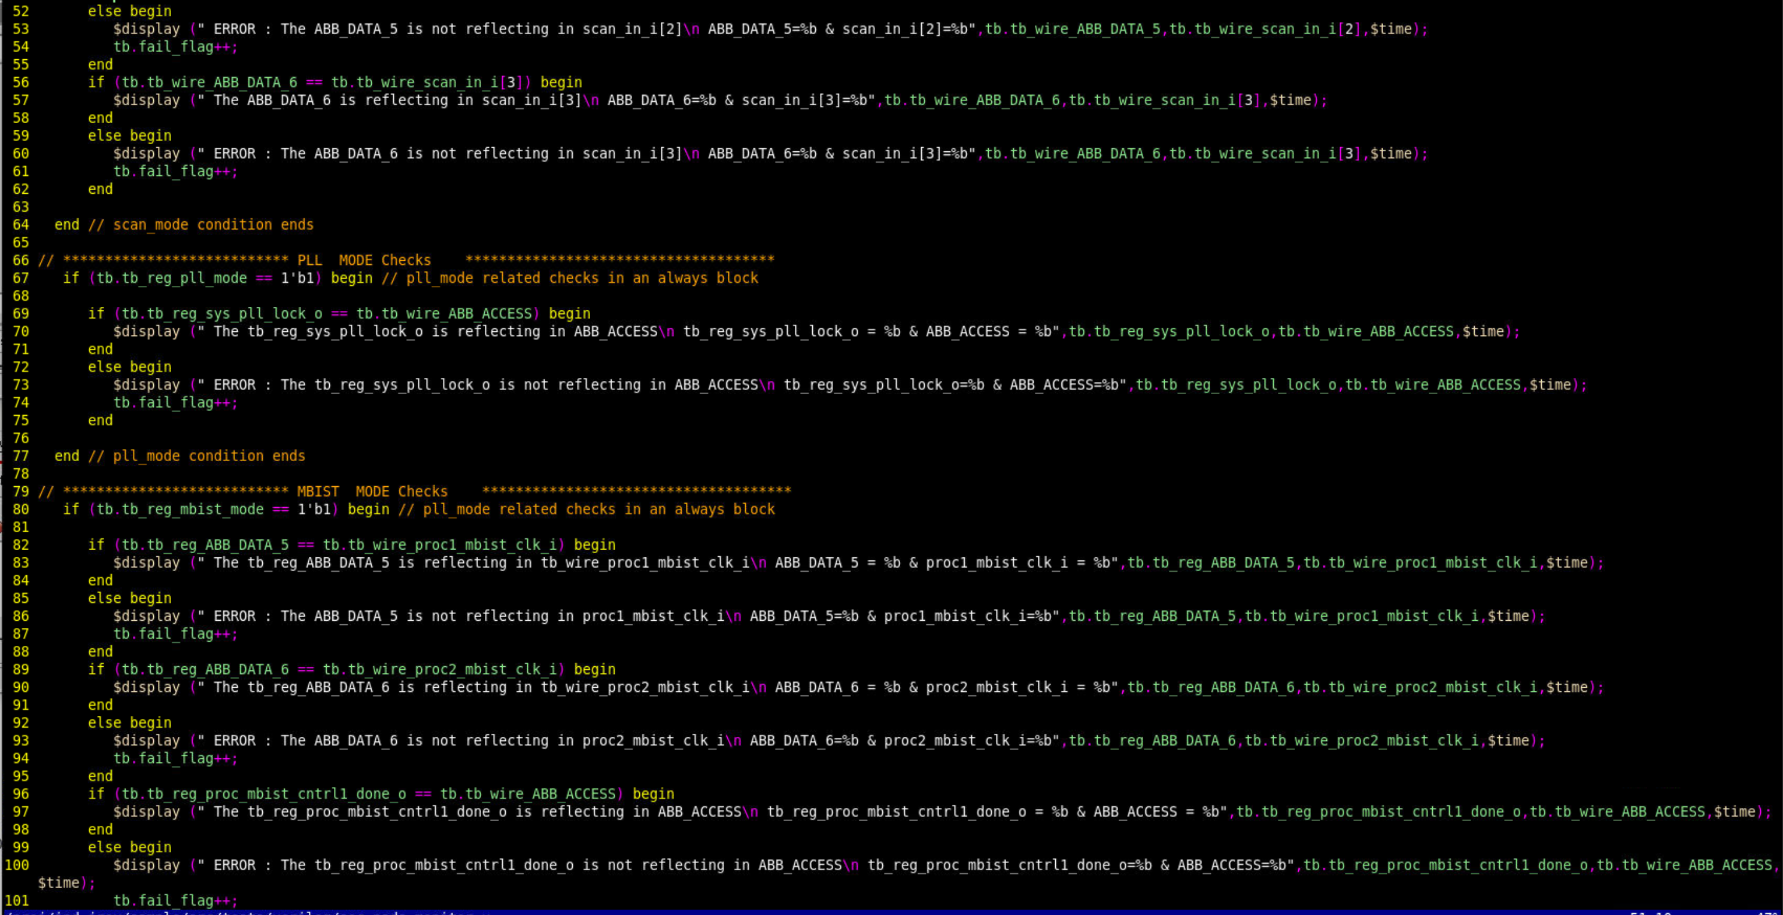

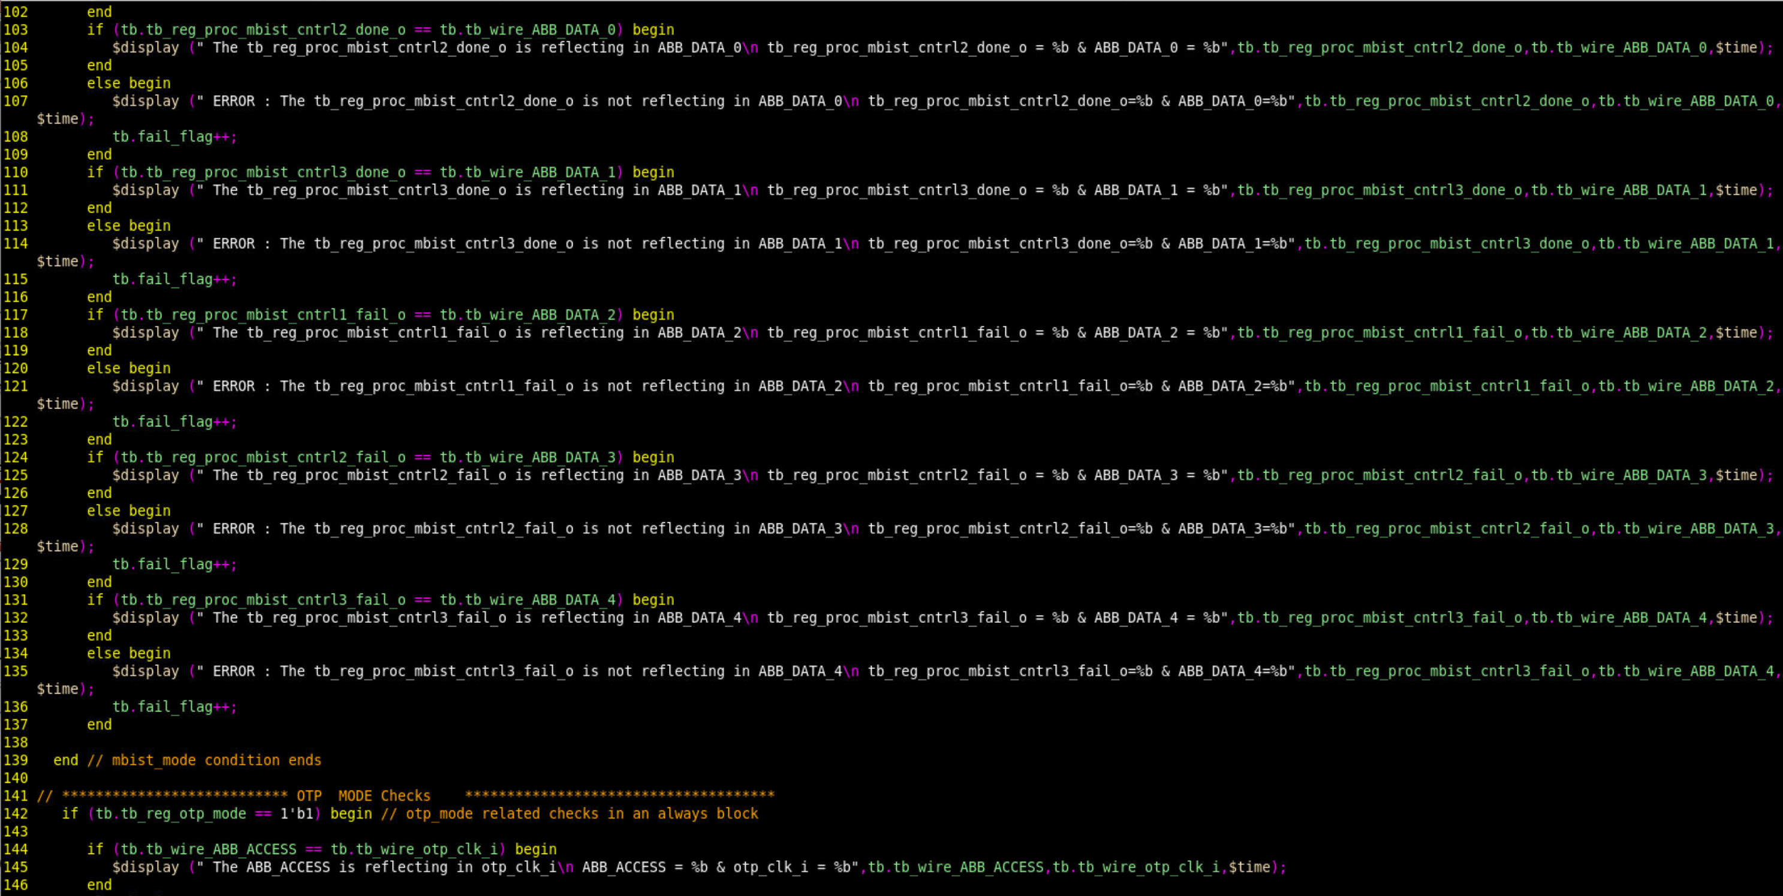

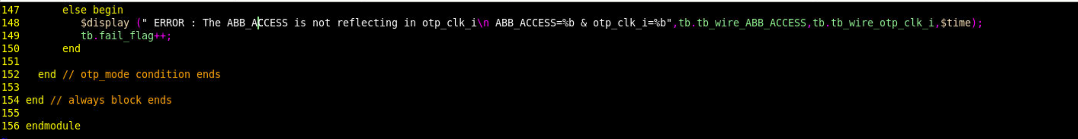

Testcases are written in separate file individually. Test_scan_mode.v, test_pll_mode.v, test_otp_mode.v etc .. one of the testcase file is given below.

Test_mbist_mode.v

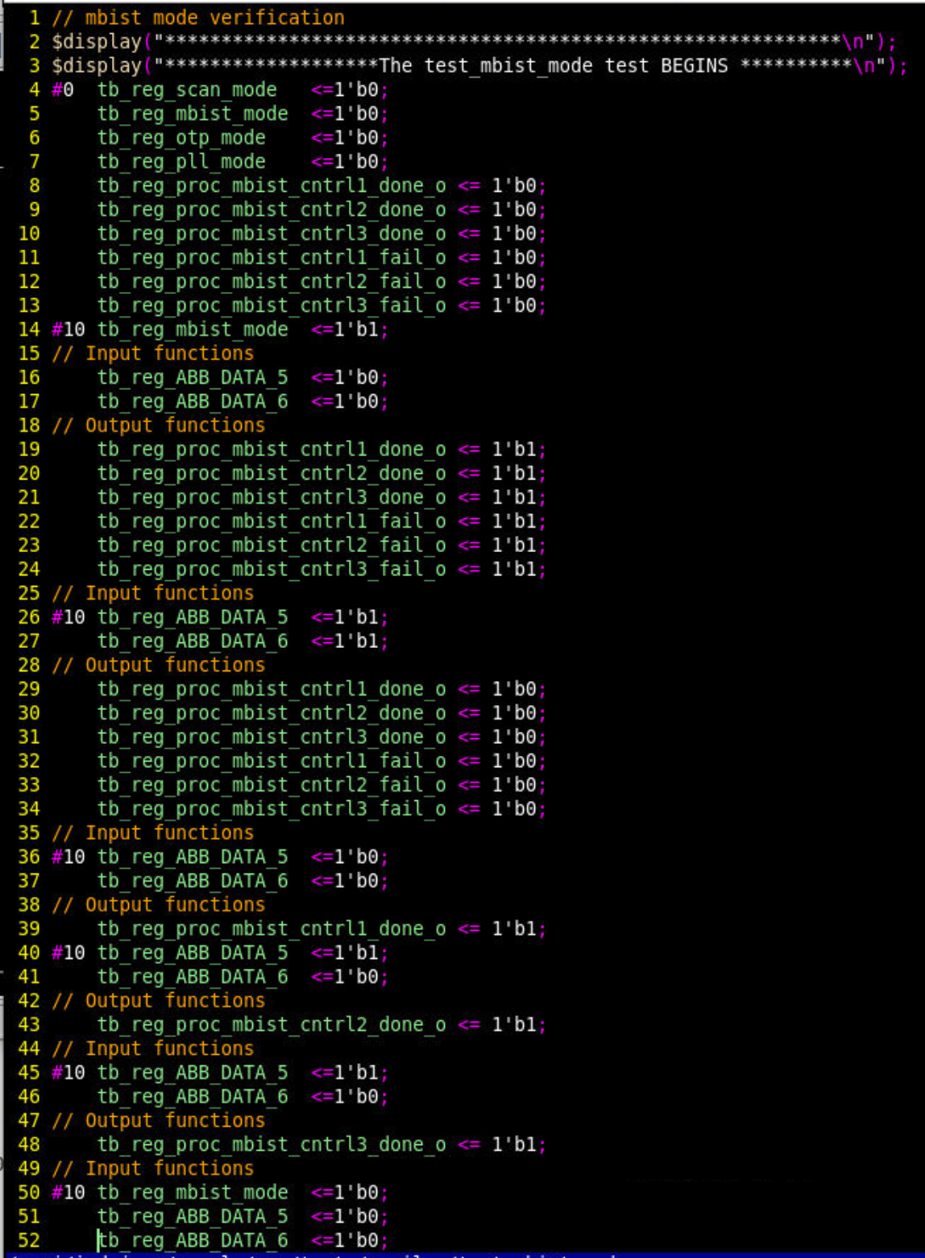

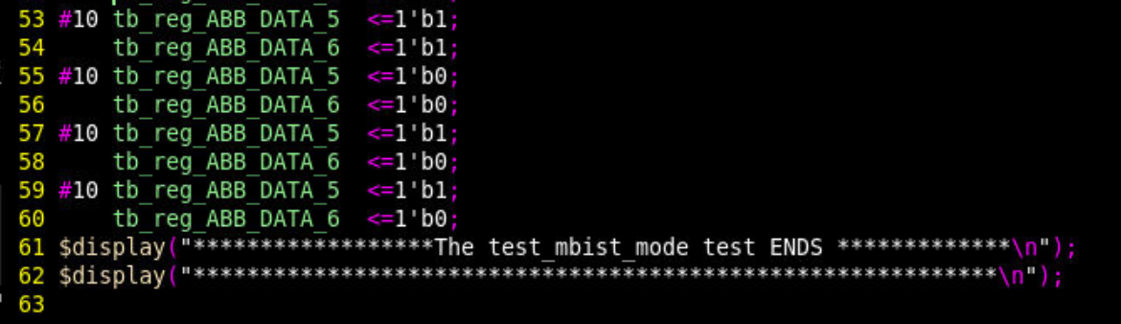

Otp_test_mode.v

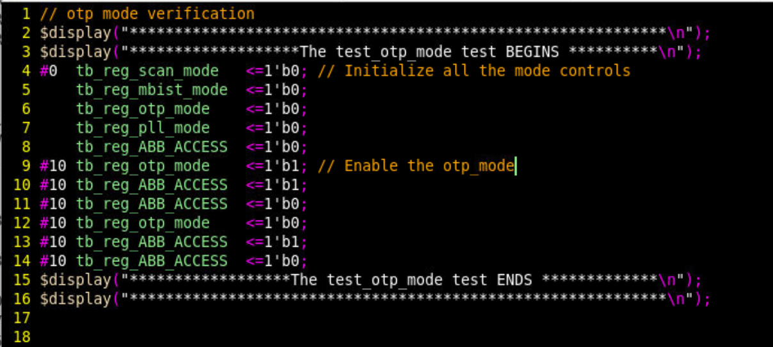

I have kept these files in the appropriate folders and created a script to simulate them. The run script is given below. I don’t have the questa simulator in my client laptop. So used the xcelium tool from cadence to simulate it. The run_sim script is given below

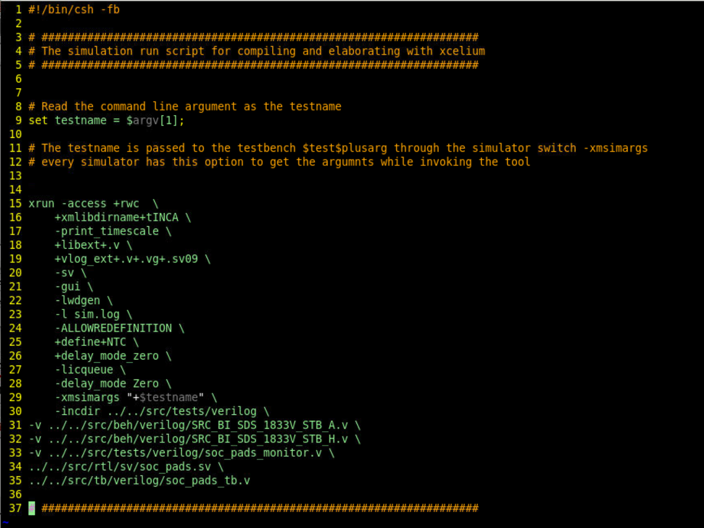

I run the script in the command line as below

$./run_sim test_scan_test

The above will pass the test_scan_test to the testbench and include the appropriate testcase file.

The result will look like the below in the tool transcript/log file as below for the otp_mode

$./run_sim test_otp_mode

